**D3 Project Proposal**

Team Members

1. Leroy Springer
2. Wiafe Busia
3. Daphne Mixon-Tinsley

Project Details

The visualization project we are working on will be a customer D3.js chart. We are going to create an Alluvial diagram showing the SuperBowl matchups and stats from 1967 – 2018.

Sample Alluvial Diagram: <http://www.brightpointinc.com/2015-nfl-predictions/>

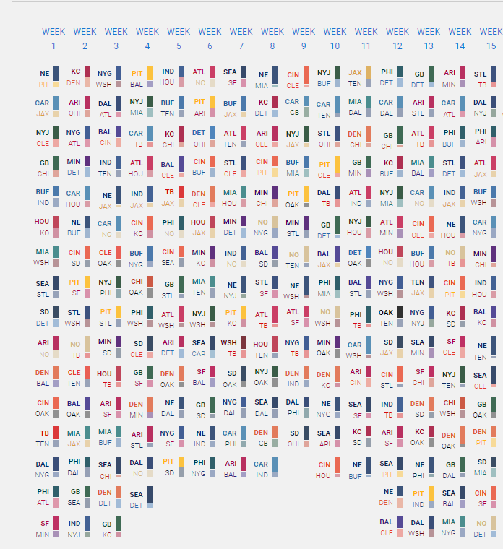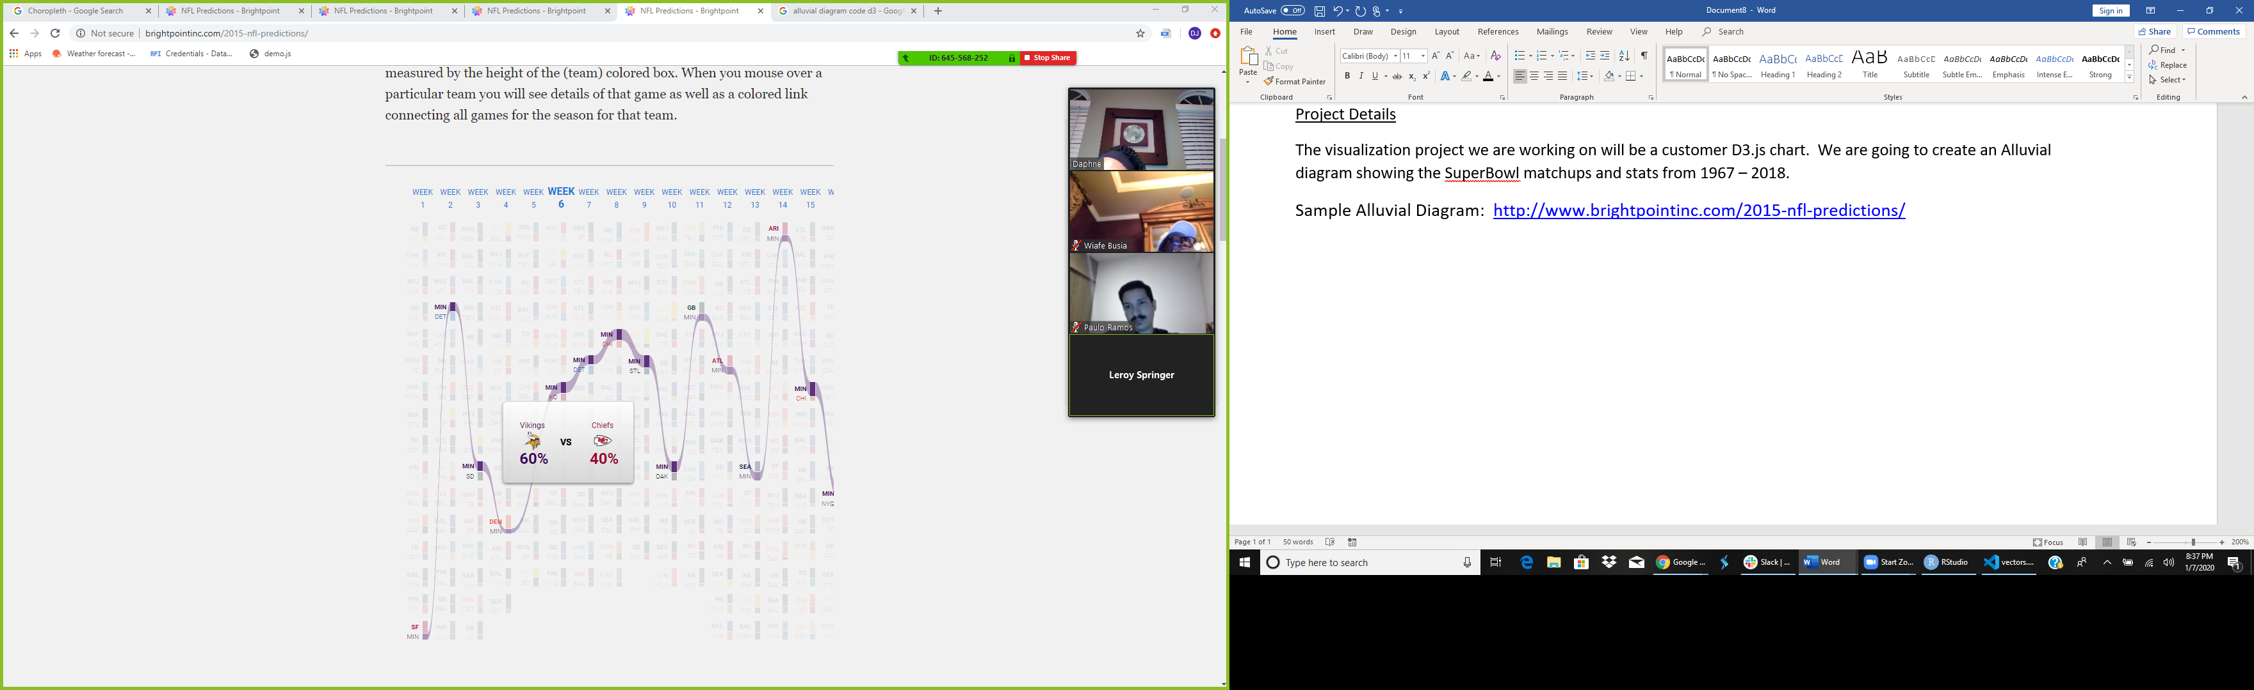

Kaggle: TV, Halftime Shows and The Big Game: <https://www.kaggle.com/achyutbabu/tv-halftime-shows-and-the-big-game#halftime_musicians.csv>

Github Repository: <https://wabsons.github.io/D3-challenge-Project>